# Applecross Senior High School

### Semester One Examination, 2018

### Question/Answer booklet

# MATHEMATICS

**SOLUTIONS**

**METHODS**

**UNIT 1**

## Section Two:

## Calculator-assumed

|  |  |  |  |  |  |  |  |  |  |  |
| --- | --- | --- | --- | --- | --- | --- | --- | --- | --- | --- |
| Student number: In figures |  |  |  |  |  |  |  |  |  |  |

In words

Your name

## Time allowed for this section

Reading time before commencing work: ten minutes

Working time: one hundred minutes

## Materials required/recommended for this section

***To be provided by the supervisor***

This Question/Answer booklet

Formula sheet (retained from Section One)

***To be provided by the candidate***

Standard items: pens (blue/black preferred), pencils (including coloured), sharpener,  
correction fluid/tape, eraser, ruler, highlighters

Special items: drawing instruments, templates, notes on two unfolded sheets of A4 paper, and up to three calculators approved for use in this examination

## Important note to candidates

No other items may be taken into the examination room. It is **your** responsibility to ensure that you do not have any unauthorised material. If you have any unauthorised material with you, hand it to the supervisor **before** reading any further.

## Structure of this paper

|  |  |  |  |  |  |
| --- | --- | --- | --- | --- | --- |
| Section | Number of questions available | Number of questions to be answered | Working  time (minutes) | Marks available | Percentage of examination |
| Section One:  Calculator-free | 8 | 8 | 50 | 52 | 35 |
| Section Two:  Calculator-assumed | 13 | 13 | 100 | 98 | 65 |
|  | | |  | **Total** | 100 |

## Instructions to candidates

1. The rules for the conduct of examinations are detailed in the school handbook. Sitting this examination implies that you agree to abide by these rules.

2. Write your answers in this Question/Answer booklet.

3. You must be careful to confine your response to the specific question asked and to follow any instructions that are specified to a particular question.

4. Supplementary pages for the use of planning/continuing your answer to a question  
have been provided at the end of this Question/Answer booklet. If you use these pages to continue an answer, indicate at the original answer where the answer is continued, i.e. give the page number.

5. Show all your working clearly. Your working should be in sufficient detail to allow your answers to be checked readily and for marks to be awarded for reasoning. Incorrect answers given without supporting reasoning cannot be allocated any marks. For any question or part question worth more than two marks, valid working or justification is required to receive full marks. If you repeat any question, ensure that you cancel the answer you do not wish to have marked.

6. It is recommended that you do not use pencil, except in diagrams.

7. The Formula sheet is not to be handed in with your Question/Answer booklet.

Section Two: Calculator-assumed 65% (98 Marks)

This section has**thirteen (****13)** questions. Answer **all** questions. Write your answers in the spaces provided.

Working time: 100 minutes.

Question 9 (4 marks)

The graphs of , and are shown below.

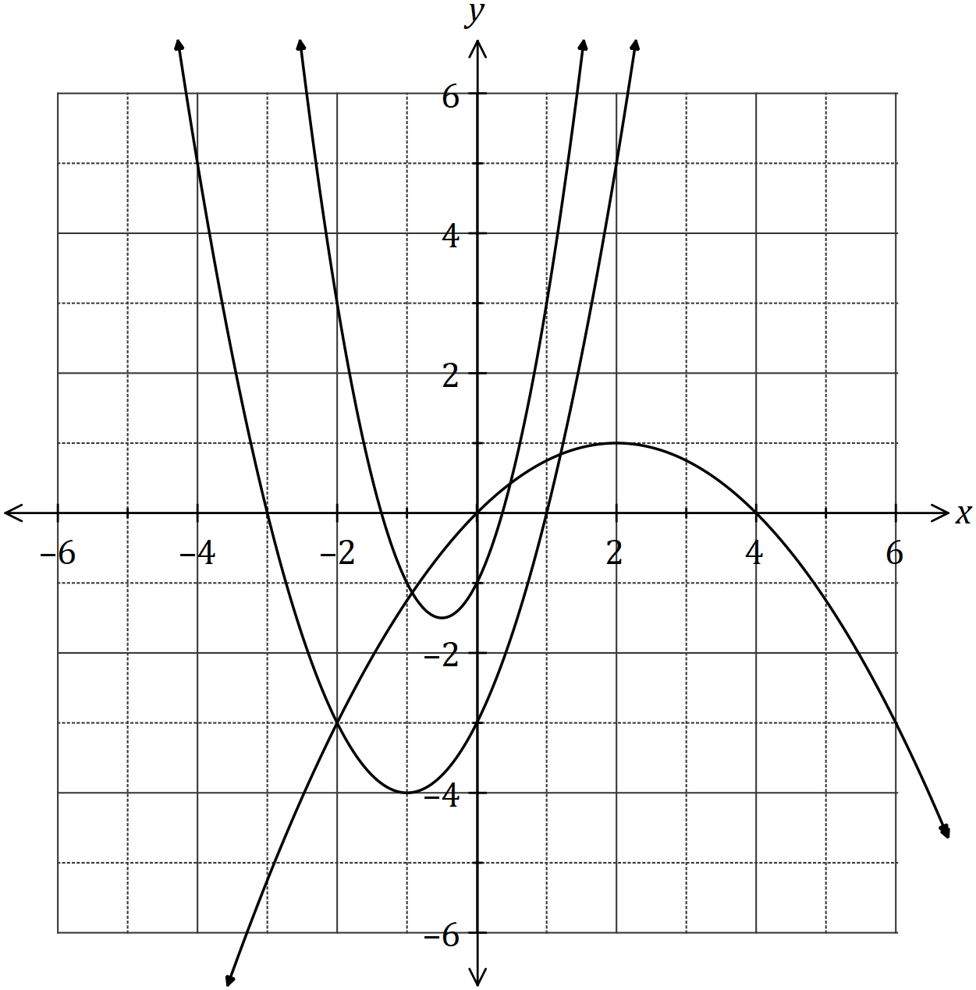

Determine the values of the constants and .

|  |
| --- |
| **Solution** |
|  |
| **Specific behaviours** |
| ✓ uses point on inverted parabola  ✓ value of  ✓ value of  ✓ value of |

Question 10 (7 marks)

(a) The graph of a relationship is circular, as shown below.

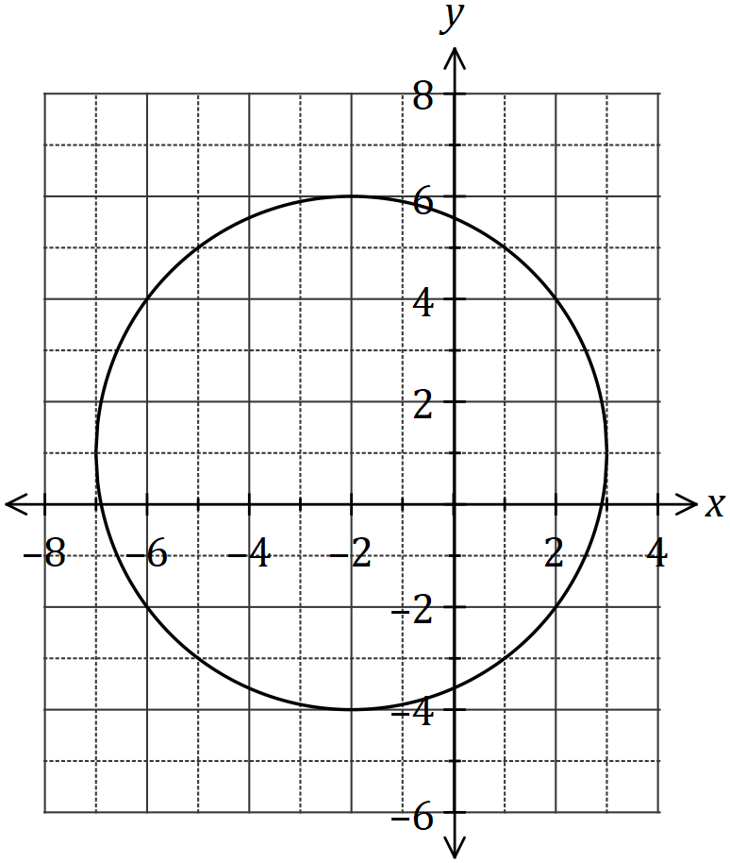

Determine the equation of this circle in the form , where and are constants. (4 marks)

|  |
| --- |
| **Solution** |
|  |
| **Specific behaviours** |
| ✓ indicates centre  ✓ indicates radius  ✓ factored form  ✓ re-arranges as required |

(b) The line intersects the circle at the points and . Show that the line passes through the centre of the circle, and hence determine the distance . (3 marks)

|  |
| --- |
| **Solution** |
|  |
| **Specific behaviours** |
| ✓ correct substitution  ✓ indicates is diameter  ✓ correct distance |

Question 11 (6 marks)

A thin pole stands vertically in the middle of a level playing ground. From point on the ground, the angle of elevation to the top of the pole, , is 18º.

From point , also on the ground but 5.35 metres further from the foot of the pole than , the angle of elevation to the top of the pole is 15º.

(a) Draw a sketch to represent this information. (1 mark)

|  |
| --- |
| **Solution** |
|  |
| **Specific behaviours** |
| ✓ sketch with right-angle, two given angles and distance AB |

(b) Showing use of trigonometry, determine the height of the post. (5 marks)

|  |
| --- |
| **Solution** |
|  |
| **Specific behaviours** |
| ✓ angle  ✓ equation using sine rule  ✓ solves for AT  ✓ use of trig in right triangle  ✓ determines h |

Question 12 (7 marks)

Let and , where and are constants.

The graph of is shown below.

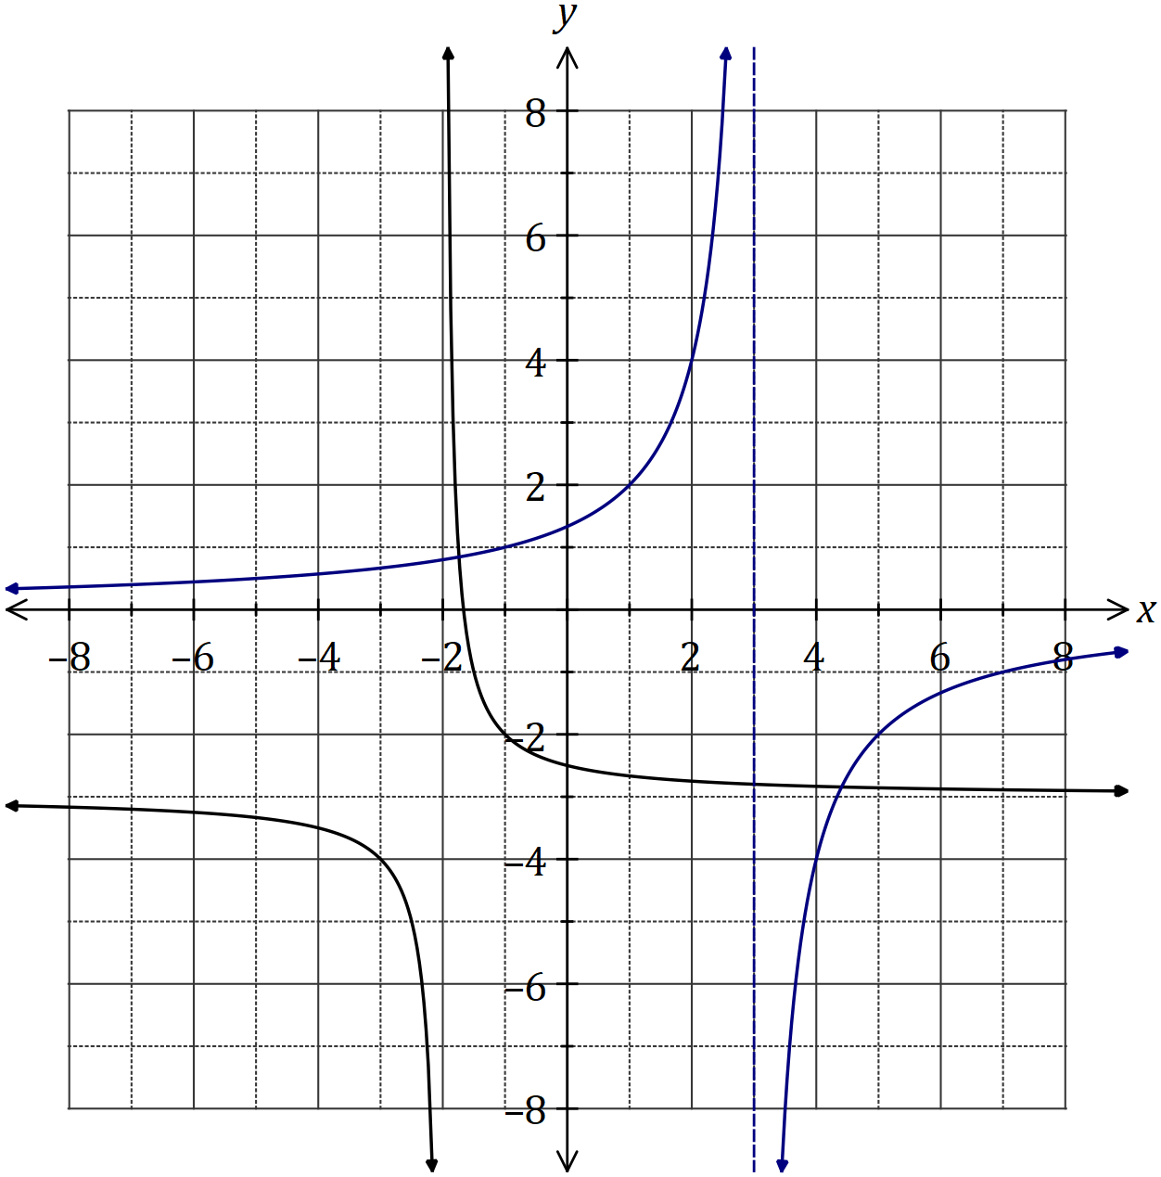

|  |
| --- |
| **Solution** |
| See graph |
| **Specific behaviours** |
| ✓ asymptotes  ✓ y-intercept  ✓ accuracy *[i.e. thu' at least 3 of (-1,1), (1,2), (2,4), (4,-4) or (7,-1)]* |

(a) Sketch the graph of on the axes above. (3 marks)

(b) Determine the values of and . (2 marks)

|  |
| --- |
| **Solution** |
|  |
| **Specific behaviours** |
| ✓ value of  ✓ value of |

(c) Solve the equation , giving your solution(s) to one decimal place. (2 marks)

|  |
| --- |
| **Solution** |
|  |
| **Specific behaviours** |
| ✓ one solution  ✓ second solution  *(Rounding for guidance only but penalise answers given as coordinates)* |

Question 13 (6 marks)

(a) Determine the equation of the axis of symmetry for the graph of .

(2 marks)

|  |
| --- |
| **Solution** |
|  |
| **Specific behaviours** |
| ✓ indicates use of formula  ✓ correct equation |

(b) The graph of passes through the points and . Determine the values of the constants and . (4 marks)

|  |
| --- |
| **Solution** |
| Solve simultaneously using CAS |
| **Specific behaviours** |
| ✓ substitutes first point  ✓ substitutes second point  ✓ solves for  ✓ solves for |

Question 14 (10 marks)

A logo with triangular outline contains a shaded segment bounded by the straight line and the circular arc with centre and radius cm, as shown below.

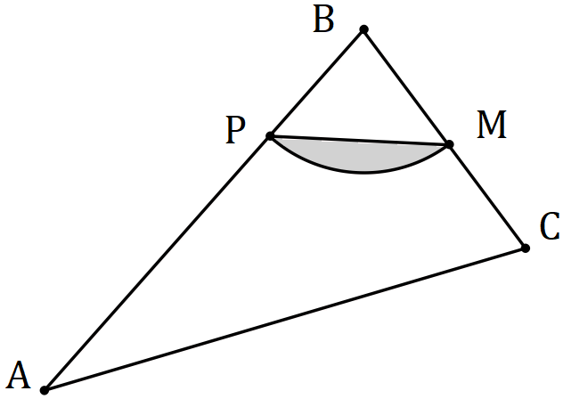

Given that , and is the midpoint of , determine

(a) the size of in degrees. (1 mark)

|  |
| --- |
| **Solution** |
|  |
| **Specific behaviours** |
| ✓ converts angle |

(b) the area of the shaded segment. (2 marks)

|  |
| --- |
| **Solution** |
|  |
| **Specific behaviours** |
| ✓ indicates substitution into segment area formula  ✓ evaluates area |

(c) the perimeter of the shaded segment. (3 marks)

|  |
| --- |
| **Solution** |
|  |
| **Specific behaviours** |
| ✓ calculates arc length  ✓ indicates use of cosine rule to find  ✓ evaluates and states perimeter |

(d) the area of triangle . (4 marks)

|  |
| --- |
| **Solution** |
|  |
| **Specific behaviours** |
| ✓ indicates use of equation to find second angle  ✓ evaluates second angle and indicates use in sin rule  ✓ evaluates second side  ✓ evaluates triangle area |

Question 15 (9 marks)

(a) The graphs of the following, where and are constants, are shown below.

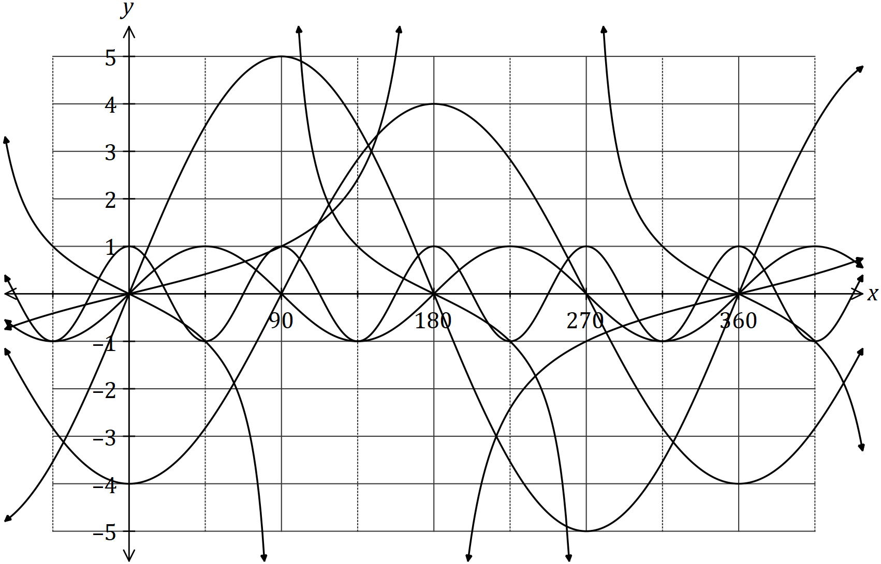

State the values of and . (6 marks)

|  |  |
| --- | --- |
| Constant | Value |
|  | 2 |
|  | -4 |
|  | 0.5 |
|  | 5 |
|  | 4 |
|  | -1 |

|  |
| --- |
| **Solution** |
| See table |
| **Specific behaviours** |
| ✓ each value |

(b) Calculate the acute angle in degrees between the lines and , rounding your answer to one decimal place. (3 marks)

|  |
| --- |
| **Solution** |
|  |
| **Specific behaviours** |
| ✓ angle of inclination of first line  ✓ angle of inclination of second line  ✓ acute angle, to one decimal place |

Question 16 (6 marks)

(a) The graph of is shown in bold below. The graphs of and are also shown, where and are constants.

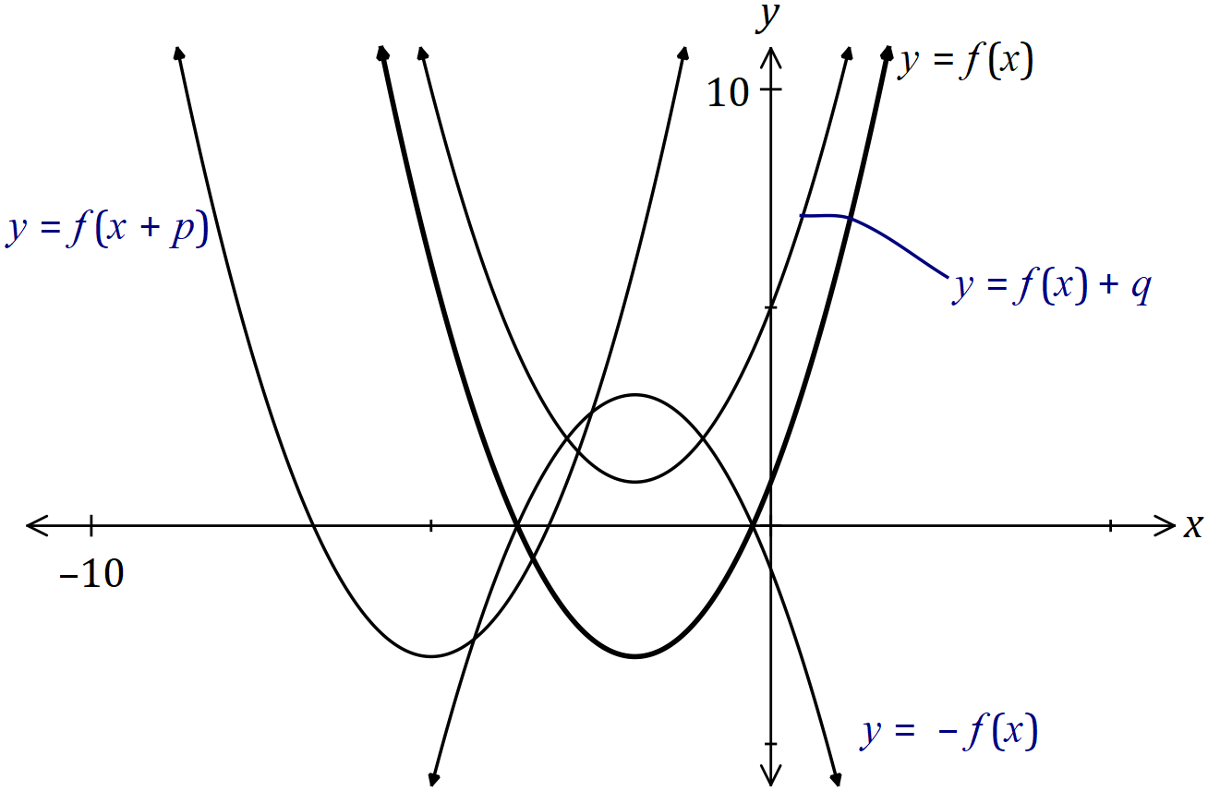

|  |
| --- |
| **Solution** |
| See graph |
| **Specific behaviours** |
| ✓✓✓ each correct label |

Clearly label the remaining graphs with or .

(3 marks)

(b) The one-to-one relation has domain and range given by and respectively. Determine the values of constants and . (3 marks)

|  |
| --- |
| **Solution** |
|  |
| **Specific behaviours** |
| ✓ value of  ✓ indicates  ✓ solves for value of |

Question 17 (9 marks)

The wind speed at a weather station, metres per second, hours after recording began, can be modelled by the function

(a) Calculate the wind speed when . (1 mark)

|  |
| --- |
| **Solution** |
|  |
| **Specific behaviours** |
| ✓ value |

(b) Sketch the graph of wind speed against time on the axes below. (4 marks)

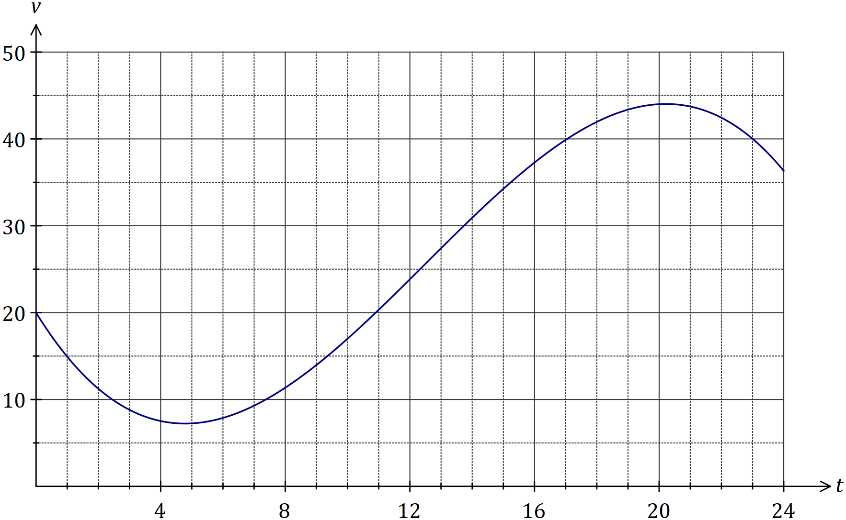

|  |
| --- |
| **Solution** |
| See graph |
| **Specific behaviours** |
| ✓ and  ✓ min at  ✓ max at  ✓ reasonable curve |

(c) During the 24-hour period, determine

(i) the time at which the wind speed was greatest. (1 mark)

|  |
| --- |
| **Solution** |
|  |
| **Specific behaviours** |
| ✓ value *(at least 1dp)* |

(ii) the minimum wind speed. (1 mark)

|  |
| --- |
| **Solution** |
|  |
| **Specific behaviours** |
| ✓ value *(at least 1 dp)* |

(iii) the length of time, in hours and minutes, that the wind speed was increasing.

(2 marks)

|  |
| --- |
| **Solution** |
|  |
| **Specific behaviours** |
| ✓ interval in hours  ✓ interval in hours and minutes |

Question 18 (6 marks)

(a) Part of the graph of is shown below, where , and and are constants.

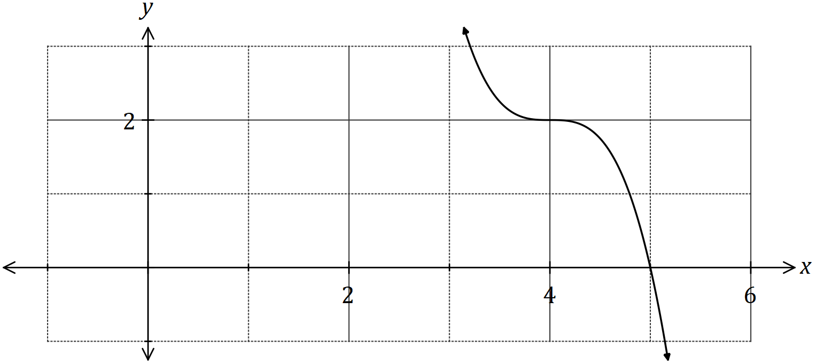

(i) State the degree of . (1 mark)

|  |
| --- |
| **Solution** |
|  |
| **Specific behaviours** |
| ✓ correct degree |

(ii) Determine the value of . (1 mark)

|  |
| --- |
| **Solution** |
|  |
| **Specific behaviours** |
| ✓ correct value |

(iii) Determine . (2 marks)

|  |
| --- |
| **Solution** |
|  |
| **Specific behaviours** |
| ✓ indicates value of  ✓ evaluates |

(b) Another function is given by .

Describe how to obtain the graph of from the graph of . (2 marks)

|  |
| --- |
| **Solution** |
| Translate graph 8 units to the left. |
| **Specific behaviours** |
| ✓ uses translation  ✓ indicates distance and direction |

**Question 19 (13 marks)**

(a) The cross-section of a wooden hand rail is formed by the intersection of two quadratic functions shown below. The upper curve is modelled by the equation 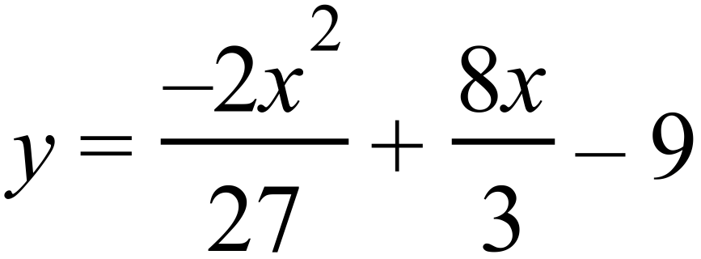 .

The equation of the lower curve is a quadratic of the form 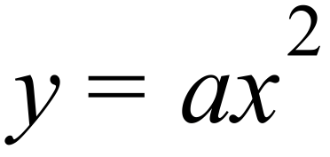 .

The two curves meet at 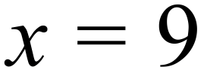 .

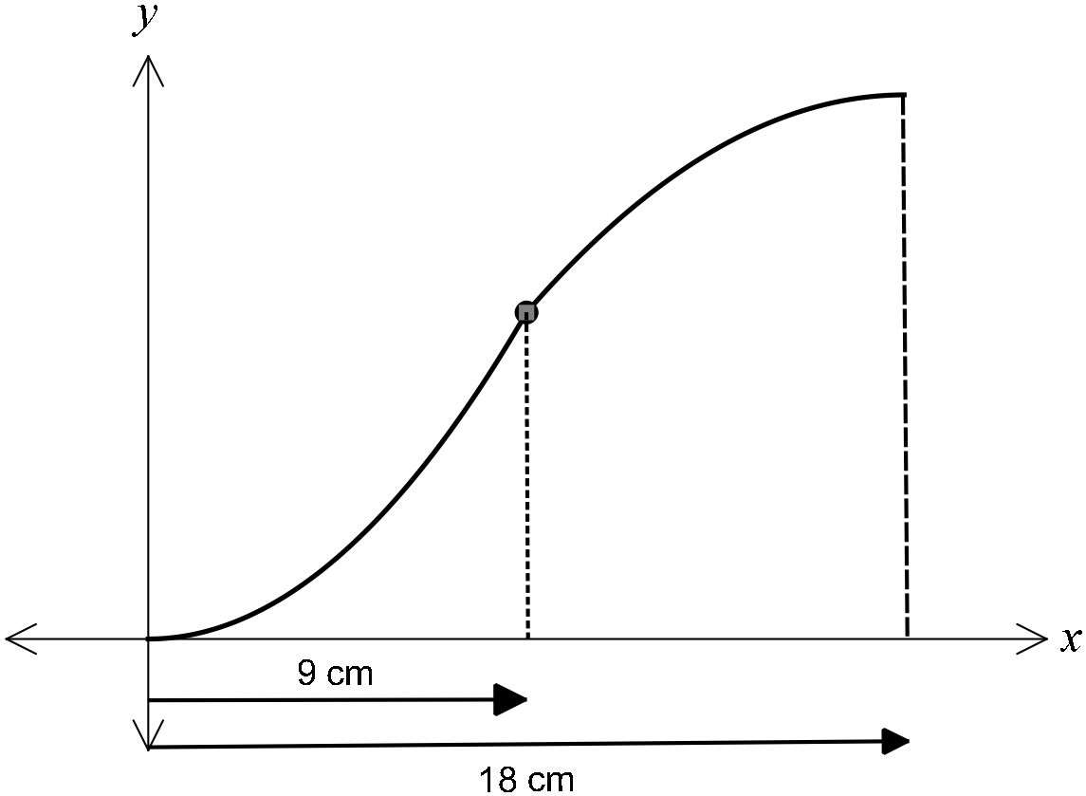

(i) Determine the coordinates of the point where the two curves meet. (1 marks)

|  |
| --- |
| **Solution** |
| substitute  into upper curve and get  therefore coordinates are (9, 9) |
| **Specific behaviours** |
| * ✓ substitutes x = 9 into upper curve and states coordinates |

(ii) Determine  and hence state the equation of the lower curve (2 marks)

|  |
| --- |
| **Solution** |
| using the coordinate (9, 9) |
| **Specific behaviours** |
| * ✓ substitutes x = 9 into lower curve to obtain the value of a * ✓ states equation of lower curve |

(iii) If the hand rail was moved up 3 cm, determine the new equations of the upper

and lower curves. (1 marks)

|  |
| --- |
| **Solution** |
| new upper curve:  new lower curve: |
| **Specific behaviours** |
| * ✓ states equation of new upper curve and states equation of new lower curve |

(b) Determine the equation

(i) of the line passing through the point 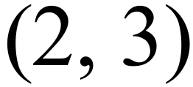 and parallel to the line with

equation 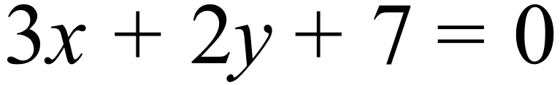 (2 marks)

|  |
| --- |
| **Solution** |
|  |
| **Specific behaviours** |
| * ✓ calculates gradient * ✓ uses the given point to calculate c and states equation |

(ii) of the line which is the reflection of the line 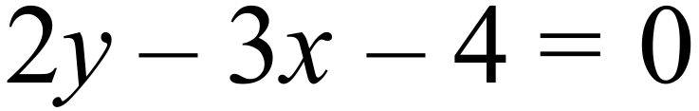 in the y-axis (2 marks)

|  |
| --- |
| **Solution** |
| Or note the  is replaced with. ⇒ line is |
| **Specific behaviours** |
| * ✓ calculates gradient * ✓ uses the given point to calculate c and states equation |

(c) Consider a rope fixed at B and tightly wrapped around a disc A as shown in the diagram below.

|  |
| --- |
| **Solution** |
| ∴length of major arc MN = (2π 2.462) x 10 = 38.213  Hence the length of the rope  cm |
| **Specific behaviours** |
| * ✓ calculates the straight lengths MB and MN * ✓ calculates the angle MAN * ✓ calculates the reflex angle MAN * ✓ calculates the length of the major arc * ✓ calculates the total rope length |

Given that disc A has a radius of 10 cm and the distance of B from the nearest edge of

disc A is twice the radius of disc A, determine the length of the rope. (5 marks)

Question 20 (7 marks)

Consider the points with coordinates and that lie in the first and second quadrants respectively of the unit circles shown below, where and are acute angles.

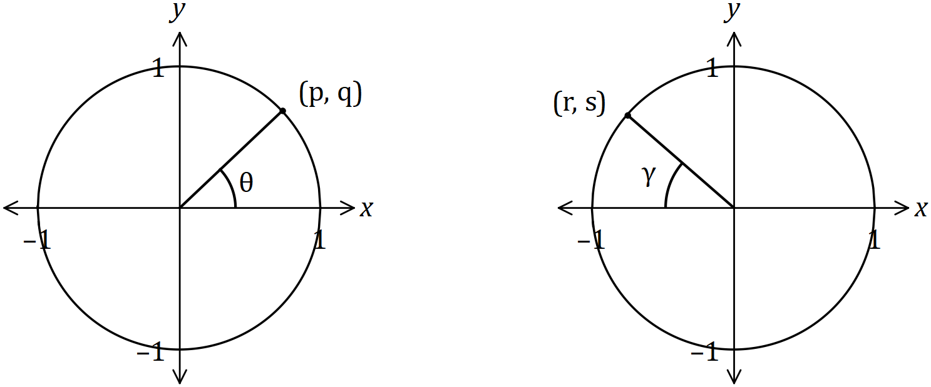

Determine the following in terms of and , simplifying your answers where possible.

(a) . (1 mark)

|  |
| --- |
| **Solutions** |
| (i)  (ii)  (iii)  (iv) |
| **Specific behaviours** |
| ✓ each correct response |

(b) . (1 mark)

(c) . (2 mark)

(d) . (1 mark)

|  |
| --- |
| **Solution** |
|  |
| **Specific behaviours** |
| ✓ ✓ correct expression |

(e) . (2 marks)

Question 21 (8 marks)

(a) For a given set of numbers the set of points  is defined as follows:



1. State the Domain of  (1 mark)

|  |
| --- |
| **Solution** |
| Hence domain of  = ={0,1,2, …,10} |
| **Specific behaviours** |
| * ✓ identifies correct domain of |

1. State the Range of . (2 marks)

|  |
| --- |
| **Solution** |
| Range of ={0,1,2,3,4} |
| **Specific behaviours** |
| * ✓ provides a full listing of the elements of * ✓ states the correct range of |

(b) If the set is redefined as follows:



1. List the elements of  (2 mark)

|  |
| --- |
| **Solution** |
|  |
| **Specific behaviours** |
| * ✓ ✓ provides a listing of the elements of |

1. State the Range of. (1 marks)

|  |
| --- |
| **Solution** |
| Range of  = ={0,1,2, …,10} |
| **Specific behaviours** |
| * ✓ states the correct range of |

(c) Comment on whether either of  would qualify to be called a function?

Justify your comment. (2 marks)

|  |
| --- |
| **Solution** |
| is a function, is not as it does not satisfy the vertical line test when graphed (or it has multiple  vales for some  values i.e. ((2,3) and (2,4) etc. |
| **Specific behaviours** |
| * ✓ indicates that is a function and that  is not * ✓ states a valid reason |

Supplementary page

Question number: _________

Supplementary page

Question number: _________

© 2018 WA Exam Papers. Applecross Senior High School has a non-exclusive licence to copy and communicate this document for non-commercial, educational use within the school. No other copying, communication or use is permitted without the express written permission of WA Exam Papers. SN002-112-4.